

**FINAL PROJECT REPORT**

*On*

**IOT BASED WATER LEVEL MONITORING**

**& ALERT SYSTEM**

***Submitted by***

**RAJAN KUMAR, BHUPENDRA SINGH, ANIKET KUMAR**

**UNDER THE GUIDANCE OF**

**DR. AVNISH BORA**

***in partial fulfilment for the award of* BACHELOR OF TECHNOLOGY IN**

**ELECTRONICS AND COMMUNICATION ENGINEERING**

*from*

**BIKANER TECHNICAL UNIVERSITY**

**DEPARTMENT OF**

**ELECTRONICS AND COMMUNICATION ENGINEERING**

**JODHPUR INSTITUTE OF ENGINEERING AND TECHNOLOGY**

**MOGRA, N. H. 65, PALI ROAD,**

**JODHPUR-342802**

**BATCH 2020-24**



**DEPARTMENT OF ELECTRONIC AND COMMUNICATION ENGINEERING**

Date:

**CERTIFICATE**

This is to certify that this project report entitled “IOT BASED WATER LEVEL MONITORING & ALERT SYSTEM” by BHUPENDRA SINGH, RAJAN KUMAR, ANIKET KUMAR submitted in partial fulfilment of the requirements for the degree of Bachelor of Technology in Electronics & Communication Engineering of the Jodhpur institute of Engineering & Technology, Jodhpur, during the academic year 2023-24, is a bonafide record of work carried out under my guidance and supervision.

Guide HOD, ECE

(Dr. Avnish Bora) (Dr. Laxmi Chaudhary)

Date:

Place: JODHPUR

# ACKNOWLEDGEMENT

I extend my heartfelt gratitude to Dr. Avnish Bora, our esteemed project guide, for his invaluable guidance, unwavering support, and mentorship throughout the development of the IoT Based Water level monitoring & alert system at Jodhpur Institute of Engineering & Technology Dr. Avinish Bora expertise, encouragement, and dedication have been instrumental in shaping this project. His insightful suggestions, constant motivation, and constructive feedback have significantly contributed to the successful completion of this endeavour. I am sincerely thankful to Dr. Avnish Bora for his time, patience, and commitment in nurturing our ideas and steering us towards excellence. His mentorship has been sources of inspiration, enabling us to navigate challenges and accomplish our goals. I also express my gratitude to the institution for providing us with the resources and environment conducive to learning and innovation. Lastly, I acknowledge the support of my peers and colleagues who collaborated tirelessly, making this project a reality.

Thank you once again, Dr. Avnish Bora, for being an exceptional guide and mentor.

Rajan kumar

Bhupendra Singh

Aniket kumar

# ABSTRACT

The IOT-based Water Level Monitoring & Alert System is an innovative system that will inform users about the level of liquid and prevent it from overflowing; it also indicates water volume, and percentage. To demonstrate this, the system makes use of containers, where ultrasonic sensors are placed over the containers to detect the liquid level and compare it with the container’s depth. The system makes use of an ESP32 microcontroller (it uses to control the system and sending data over the wireless network), an LCD screen, an Ultrasonic Sensor, and two led (for detect the water Empty and full level). The LCD screen is used to display the status of the level of liquid in the containers. The liquid level is shown in the format as numeric, gauge, chart and table to analysis the data for further use. In this system, we are using two LEDs that indicate the status of water full and empty signal and also show the status on the webpage which we can access anywhere. Thus, this system helps to prevent the wastage of water by informing people about the liquid levels in the containers. It also measures the water volume of the tank.

Table of Contents

ACKNOWLEDGEMENT 3

ABSTRACT 4

LIST OF FIGURES 6

CHAPTER 1: INTRODUCTION OF OUR PROJECT 7

1.1 Introduction 7

1.2 Circuit diagram: 8

1.3 Problem Statement: 8

1.4 Benefit of project: 9

CHAPTER 2: LITERATURE SURVEY 10

CHAPTER 3: SYSTEM REQUIREMENTS 13

3.1 Component Required: 13

3.1.1 Ultrasonic sensor: 13

3.1.2 ESP 32 microcontroller: 14

3.1.3 LCD 16*2 display: 17

3.1.4 Thing speak: 18

3.2 Working of project 19

3.2.1 Block Diagram: 20

3.2.2 Methodology: 21

3.3 Program for IoT based water monitoring & Alert system: 22

3.4 Visualization and monitoring 29

3.4.1 LCD Screen: 29

3.4.2 Thing speak: 30

3.4.3 Graphical Representation: 30

3.5 Output of IoT based water monitoring & alert System 31

3.4 Snapshots of working system and installation of system 34

REFERENCES 37

# LIST OF FIGURES

Figure 1.2 1 Circuit Diagram 8

Figure 3.1 1 Waterproof Ultrasonic sensor 13

Figure 3.1 2 Water level indicator using ultrasonic sensor 14

Figure 3.1 3 ESP32 Board 15

Figure 3.1 4 Functional block Diagram of ESP32 17

Figure 3.1 5 LCD 16*2 Display with I2C adapter 18

Figure 3.1 6 Thing Speak 18

Figure 3.1 7 Block diagram of water monitoring system 20

Figure 3.1 8 Methodology of water monitoring system 21

Figure 3.1 9 Output on LCD Display 29

Figure 3.1 10 Output on Thing Speak Server 30

Figure 3.1 11 Webpage Output 31

Figure 3.1 12 water monitoring parameters (Height, Quantity, Percentage) 32

Figure 3.1 13 Water Height chart 32

Figure 3.1 14 Tabular data (Continuous monitoring parameters) 33

Figure 3.1 15 IoT based water monitoring and alert system 34

Figure 3.1 16 Circuitry of the system 35

# INTRODUCTION OF OUR PROJECT

## 1.1 Introduction

The urgent problems of water scarcity and waste in today's global environment call for creative solutions. Water conservation is more important than ever because the world's population is growing every minute. Conventional water management systems frequently rely significantly on human resources to provide round-the-clock control, which can be time-consuming and prone to error. Here’s our solution: an advanced water level monitoring and alert system that's meant to make this operation as simple and efficient as possible for humans.

Our technology detects water levels at different depths with accuracy thanks to modern sensors that are strategically placed within storage tanks. These sensors easily communicate with a microprocessor, which transfers the data to an LCD that is easy to read. But that's not where our system ends. It uses Internet of Things technology to improve its usefulness to a new level. It enables real-time liquid level monitoring by using ultrasonic sensors mounted on top of containers. The sensors compare the liquid levels to the depths of the containers to provide accurate measurements. Because this data is transferred through a Wi-Fi modem, customers can access it remotely and updates are guaranteed promptly. Our system's main feature is its user-friendly interface, which is shown on the LCD screen and clearly illustrates the liquid level status inside the containers. This information is also available via a web page, which has color-coded markers for easy comprehension and to further improve user experience.

Our system uses LED indications in place of the standard buzzer, which is a deviation from normal alert systems. When levels surpass preset thresholds, a red LED alerts and mitigates the situation. Our water level monitoring and alarm system, which combines state-of-the-art technology with useful features to meet the pressing need for conservation in the modern world, essentially represents a paradigm shift in water management.

## 1.2 Circuit diagram:

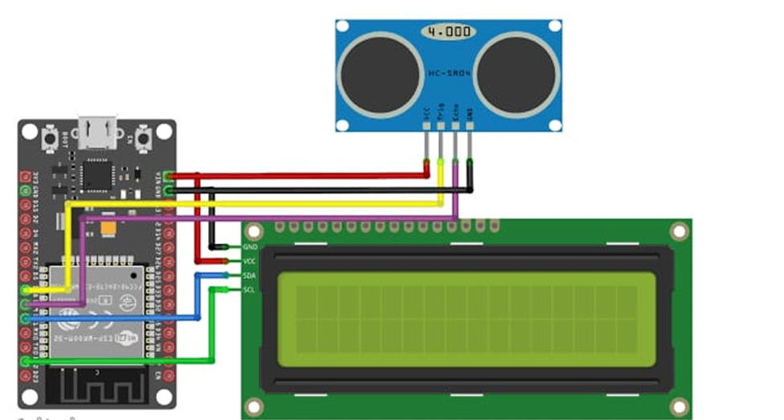

Figure 1.2 1 Circuit Diagram

## 1.3 Problem Statement:

Wasting water is a growing problem in a country like India. Today, embedded systems play an important role in the design process to ensure effective analysis and efficient operation. Due to the time complexity of electronic aspects, embedded systems have become an important part of our daily life. That's why we designed a project that uses built-in systems to measure the water level in the storage tank and display it on an LCD screen. This not only gives us the necessary information about the condition of the water tank, but also helps and reduces the work of the whole process. Our project is a contribution to solving the problems of water shortage. Implementing embedded systems also reduces the likelihood of human error.

## 1.4 Benefit of project:

Water level monitoring system are basically electronic gadgets which are used to control the functions of your pump Most of the people prefer to use fully automatic control devices to check the supply of water, The automatic water level monitoring devices are capable of controlling the functions of the motor and help to reduce the consumption of electricity, One of the main advantages of water level monitoring devices includes the ability to control power fluctuations when the motor is switched on. Most of these devices ensures uninterrupted water supply by filling the overhead tank once it is below level. The motor power is switched on when the overhead tank becomes empty and switches off automatically when the underground tank is empty or the overhead tank becomes full. In this way it becomes easy to ensure 24 hours water supply without any kind of interruption.

There are several benefits of using these devices:

* The device does not require manual controls. It can be operated automatically with the help of timer switches.
* With the use of these devices, the possibility of tanks getting over filled can be negated completely. The motor switch is automatically switched off even when the underground tank is empty.
* The use of water level monitoring devices also avoids running the pumps during odd hours, particularly at night. It also ensures maximum water supply during peak hours especially during morning hours. The special sensors and time controllers are apt in pumping the water level to its maximum before the peak hours. It also maintains the water level throughout the day.

# LITERATURE SURVEY

1. Charles A, “IOT BASED WATER LEVEL MONITORING SYSTEM USING LABVIEW”, International Journal of Pure and Applied Mathematics, Volume 118 No. 202018, 9-14 ISSN: 1311-8080 (printed version); ISSN: 1314-3395 (on-line version).

**Brief summary related to project:**

This paper illustrates a solution of water scarcity faced by many societies and world in 21st century. The proposed paper focused on IOT based monitoring system, implementation, and management of water distribution in large areas. The monitoring system was implemented by Ultrasonic sensors and Node MCU. This is non-contact water level management. By the system, water is transferred to several tanks from the ground water or dam; there water is pumped to tanks by motors. Each pump connected to each tank by solenoid valves, used to control the water flow to each tank. The solenoid valves get turned on by USB6009 (DAQ Assist) with LABVIEW. The main function of DAQ is sending digital pulses to get valves ON. Ultrasonic sensors that measure the distance of water level in the tank & the data is displayed in the IoT devices. The received date is sent to Google cloud platform. We can also retrieve the data from the webpage that will display in LAB VIEW front panel. Network of sensors has been used to buffer efficient water circulations. The included NI-DAQmx driver and configuration utility simplify configuration and measurement.

2. Neena Mani, Sudeesh T.P, Vinu Joseph, Titto V.D, Shamnas P.S, “Design and Implementation of a Automated Water Level Indicator”, International Journal of Advanced Research in Electrical, Electronics and Instrumentation Engineering 2014 Vol 3 Issue 2, February 2014.

**Brief summary related to project:**

Water level indicator is widely used in many industries and houses. In this paper a programmed microcontroller is the basic component for the water level indicator. AT mega 32A microcontroller is helps to indicate the level of water or any other conducting liquid. With the help of a LCD display we can see all the level of the water contained in a tank or in any other vessels. A liquid level sensor (transistor circuit) detects the present level of the liquid in the tank in terms of the voltage across transistor and feeds it to the microcontroller and the microcontroller generates a corresponding output text which in then displayed in the LCD. If the water level is full, then the circuit beeps through the buzzer notifying that the water level is full. The circuit is divided into two parts. First one is the microcontroller section which is kept on the breadboard and second is the transmitter section and its base is kept inside the water tank. The collector terminals of each of these transistors are connected to a +5-volt level. The emitter terminals are connected to input pins of PORT A of the microcontroller. The microcontroller continuously monitors the state of each of these input pins. If the first pin, which is the one corresponding to the quarter level of the tank is high then LCD displays “quarter”. If both the first and second pins are high, then LCD displays “half full”. Similarly, if the first three pins are high then we infer from the LCD that the water level is three quarters of the tank. Likewise, a high on all four pins displays the message “full”. Once the water tank is full, the buzzer produces a short audible sound warning the user to switch off the motor.

3. S. M. Khaled Reza, Shah A Haussamen Md. Tariq, “Microcontroller Based Automated Water Level Sensing and Controlling: Design and Implementation Issue”, Proceedings of the World Congress on Engineering and Computer Science 2010 Vol I WCECS 2010, October 20- 22, 2010, San Francisco, USA.

**Brief summary related to project:**

This paper introduces the notion of water level monitoring and management within the context of electrical conductivity of the water. More specifically, it investigates the microcontroller-based water level sensing and controlling in a wired and wireless environment. From the user’s perspective, it is required to reuse such valuable resource in a mobile application. Finally, it proposes a web and cellular based monitoring service protocol would determine and senses water level globally. To implement the system, we should use some necessary parts such as PIC 16F84A microcontroller, Crystal Oscillator, 2 capacitors having capacitance 22 pF and 27 pF, inverter, LED, water tank, water level sensor, water pump, transistor, inductor and some capacitor should be implemented. When the water is decreasing from the tank by home use, the display LED should start to become OFF one after another from the top to bottom. If all the LEDs becomes OFF that means the tank becomes empty again and the water pump should become automatically ON again exactly after the last LED becomes OFF. These operations should automatically perform as a cycle. This article focuses on displaying the available local connections and the stored remote connections through the internet & designing interactive application software for remote PC or mobile should display data in table format or in the graphical interface for integration of the wireless water level monitoring.

4. R.S. SUNMONU, M.A. SODUNKE, O.S. ABDULAI & E.A. AGBOOLA “DEVELOPMENT OF AN ULTRASONIC SENSOR BASED WATER LEVEL INDICATOR WITH PUMP SWITCHING TECHNIQUE”, International Journal for Research in Electronics & Electrical Engineering ISSN: 2208-2735

**Brief summary related to project:**

The liquid levels determination is done by electronically converting the time of arrival of echo as recorded by the receiver (R) of the ultrasonic sensor from incident waves from transmitter (T). Arduino UNO, an active microprocessor in this design is commercially available which is electronically and mechanically fragile, hence the needs to replace Arduino UNO with rugged and cost-effective fabricated units from available cheap components. This paper looks into the development and implementation of such a simple and cost-effective feedback regulator for use in applications where there are needs to real timely monitor the water levels. The aim of this present work is to develop an independent water level control system with design based on ultrasonic transducer (sensor) thereby addressing problems of untimely response and frequent breakdown of contact sensors due to surface coating and corrosion from the water medium which characterized existing water level control-based contact sensors. Our developed system controls, monitors and maintains the water level in the tank (overhead or surface) and ensures the continuous flow of water round the clock without the labour stress of manually switching the pump ON or OFF thereby saving time, electrical energy, water, and prevent overworking of the feed pump. Then on contact ultrasonic sensor is strategically positioned on the peak of the vessel thereby solving the problems of frequent replacement of contact and submersible sensor which characterize existing commercial and expensive water indicator. The module detected, controlled and maintained the level of water. The level of the water in the vessel is indicated in % of the volume holding capacity of the tank which is displayed on the Liquid Crystal Display (LCD) unit.

# SYSTEM REQUIREMENTS

## 3.1 Component Required:

3.1.1 Ultrasonic sensor: The depth of the container and the water levels are precisely measured using ultrasonic sensors. These sensors operate on the principle of emitting ultrasonic waves and measuring the time taken for the waves to bounce back, providing precise distance measurements.

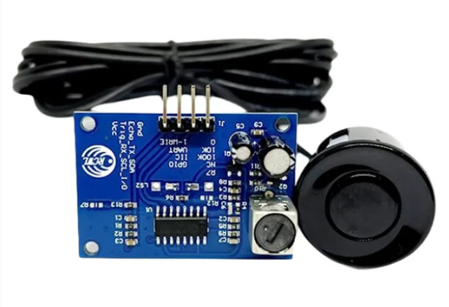

Figure 3.1 1 Waterproof Ultrasonic sensor

**Working of Ultrasonic sensor:**

When we decide to make any kind of water level sensor, the first thing that comes to mind is the electrodes that we dip into the water. Traditionally, several metal electrodes are immersed in water at different levels and a certain voltage is applied. The long-term problem with this method is that no matter how well the electrodes are treated before installation, they will corrode due to an electrochemical reaction that occurs when an electric current is passed through the water, which reacts with some of the minerals in the water. Bad idea to consume such polluted water. The resolution of the reading is limited by how many electrodes are immersed in the water. Ultrasound-based measurement overcomes all the disadvantages of using the traditional electrode method. The accuracy of the readings is +/- 3 mm and it can be used at a depth of up to 4 meters.

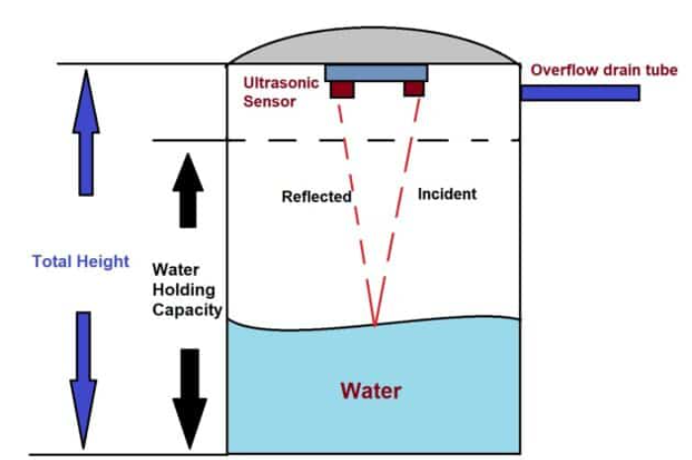

Figure 3.1 2 Water level indicator using ultrasonic sensor

Measuring the water level is the same as measuring the distance between solid surfaces, the ultrasonic sensor produces 40 kHz ultrasonic bursts that hit the water surface and are reflected back to the sensor. The time between the transmitted and received ultrasound waves is calculated by a microcontroller such as Arduino. The measured distance is converted into a percentage. The tank has two heights, the actual water capacity and the total tank height. All overhead tanks have an overflow and inlet pipe, the point below the overflow pipe is the watertight end. You must measure these two heights and enter the given program code in centimetres.

3.1.2 ESP 32 microcontroller: The brains of the system are the ESP32 microcontroller, which collects and analyses data from ultrasonic sensors. This makes communication easier between the Thing speak software, LCD panel, and sensors.

ESP32 is a series of low-cost, low-power system on chip microcontrollers with integrated Wi-Fi and dual-mode Bluetooth. The ESP32 series employs either a Ten silica Xtensa LX6 microprocessor in both dual-core and single-core variations, Xtensa LX7 dual-core microprocessor and a single-core RISC-V microprocessor and includes built-in antenna switches; RF balun, power amplifier, and low-noise receive amplifier, filters, and power-management modules. ESP32 is created and developed by Espressif Systems, a Chinese company based in Shanghai, and is manufactured by TSMC using their 40 nm process.[2] It is a successor to the ESP8266 microcontroller.

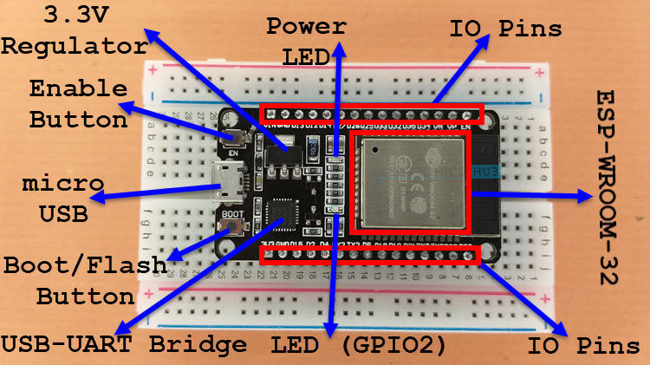

Figure 3.1 3 ESP32 Board

**Features of the ESP32 include the following:**

Processors:

* CPU: Xtensa dual-core (or single-core) 32-bit LX6 microprocessor, operating at 160 or 240 MHz and performing at up to 600 DMIPS
* Ultra-low power (ULP) co-processor
* Memory: 520 KiB RAM, 448 KiB ROM
* Wireless connectivity:
* Wi-Fi: 802.11 b/g/n
* Bluetooth: v4.2 BR/EDR and BLE (shares the radio with Wi-Fi)

Peripheral interfaces:

* 34 × programmable GPIOs
* 12-bit SAR ADC up to 18 channels
* 2 × 8-bit DACs
* 10 × touch sensors (capacitive sensing GPIOs)
* 4 × SPI
* 2 × I²S interfaces
* 2 × I²C interfaces
* 3 × UART
* SD/SDIO/CE-ATA/MMC/eMMC host controller
* SDIO/SPI slave controller
* Ethernet MAC interface with dedicated DMA and planned IEEE 1588 Precision Time Protocol support
* CAN bus 2.0
* Infrared remote controller (TX/RX, up to 8 channels)
* Pulse counter (capable of full quadrature decoding)
* Motor PWM
* LED PWM (up to 16 channels)
* Ultra-low power analog pre-amplifier

Security:

* IEEE 802.11 standard security features all supported, including WPA, WPA2, WPA3 (depending on version) and WLAN Authentication and Privacy Infrastructure (WAPI)
* Secure boot
* Flash encryption
* 1024-bit OTP, up to 768-bit for customers
* Cryptographic hardware acceleration: AES, SHA-2, RSA, elliptic curve cryptography (ECC), random number generator (RNG)

Power management:

* Individual power domain for RTC
* 5 μA deep sleep current
* Wake up from GPIO interrupt, timer, ADC measurements, capacitive touch sensor interrupt

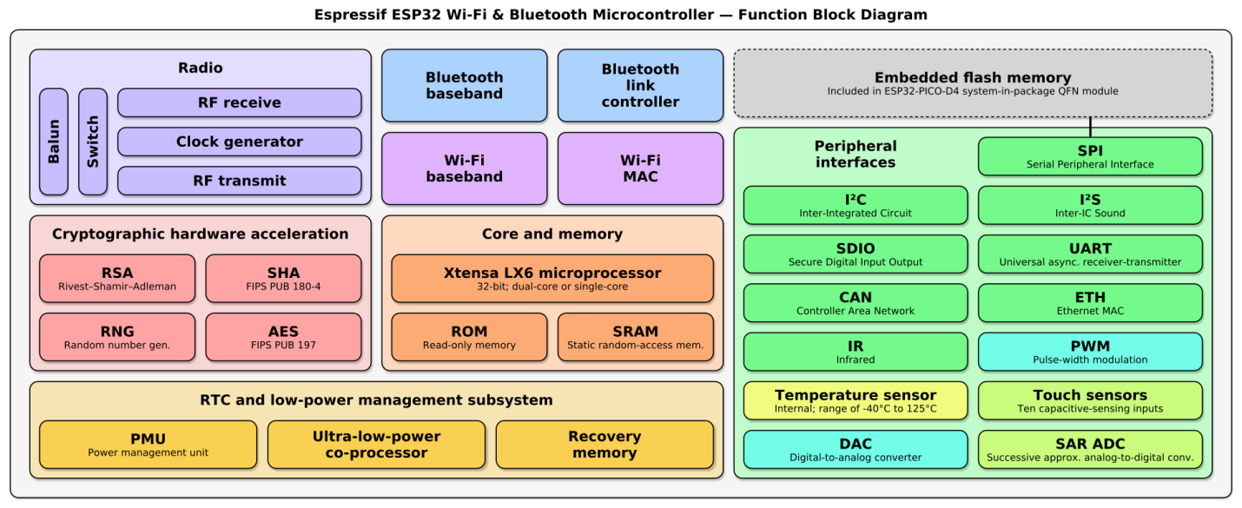

Figure 3.1 4 Functional block Diagram of ESP32

3.1.3 LCD 16*2 display:

Immediate visual information regarding water levels is available on an LCD panel. Users can easily see the current water levels without needing to access a separate device or interface. This makes it convenient for users to quickly assess the situation and take the necessary actions. The LCD screen also displays alerts and notifications for when water levels are low or when maintenance is required. This real-time information allows users to stay on top of any issues that may arise, ensuring that their water tanks are always in good working condition. Additionally, the user-friendly interface of the LCD screen makes it simple for users to navigate and understand the data being presented, further enhancing the overall user experience.

* + GND is ground pin.
  + VCC is the power supply pin. Connect it to the 5V output of the Arduino or an external 5V power supply.
  + SDA is the I2C data pin.
  + SCL is the I2C clock pin.

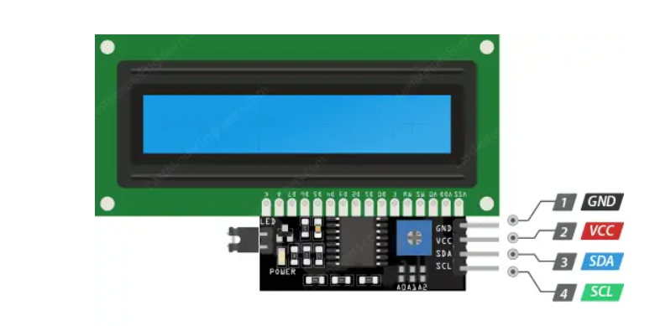

Figure 3.1 5 LCD 16*2 Display with I2C adapter

3.1.4 Thing speak: Additionally, the system also provides options for remote monitoring through a mobile app or web interface, allowing users to check on their water tanks from anywhere. This level of visualization and monitoring ensures that users are always informed and prepared to handle any potential issues with their water supply. The system integrates with thing speak software, offering a visually appealing and informative graphical representation of liquid levels. The system also allows users to set up alerts for specific thresholds, ensuring peace of mind and quick response times in case of emergencies.

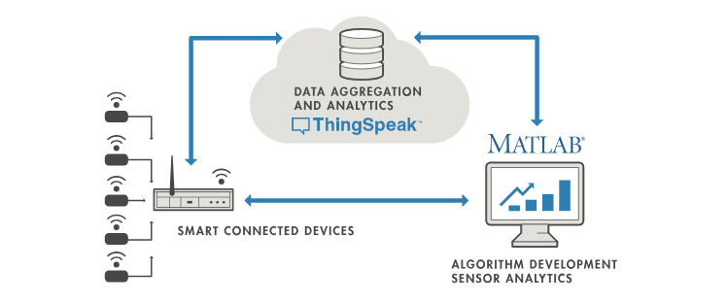

Figure 3.1 6 Thing Speak

Thing Speak is open-source software written in Ruby which allows users to communicate with internet enabled devices It facilitates data access, retrieval and logging of data by providing an API to both the devices and social network websites. Thing Speak was originally launched by ioBridge in 2010 as a service in support of IoT applications. Thing Speak has integrated support from the numerical computing software MATLAB from MathWorks, allowing Thing Speak users to analyse and visualize uploaded data using MATLAB without requiring the purchase of a MATLAB license from MathWorks.

## 3.2 Working of project

One IoT-based solution for water level monitoring is the IOT Based Water Level Monitoring and Alert System. Its main goal is to notify consumers in a timely manner when liquid levels are about to cross critical thresholds, either from overflow or depletion. The system uses ultrasonic sensors that are positioned strategically above water tanks or containers to detect and compare liquid level and container depth with accuracy.

**Ultrasonic Sensors:** These sensors are used to measure water levels and container depth with accuracy. In order to measure distance precisely, these sensors work by sending out ultrasonic waves and timing how long it takes for the waves to return.

**ESP32 Microcontroller:** Gathering and interpreting data from ultrasonic sensors, the ESP32 microcontroller is the system's brain. This makes communication easier between the Thing Speak, LCD panel, and sensors.

**Alert Mechanism:** The system contains an alert mechanism that is triggered in the event of a liquid overflow or depletion to prevent such issues. Users who receive timely alerts are empowered to act quickly. Two ways are used to send the alert: first, to make sure there is no liquid overflow by checking the water level everywhere, and second, to turn on the LED when it is empty and fully charged.

**Significance of the Alert System**

The alert feature of the IOT-based Water Level Monitoring and Alert System is essential for reducing difficulties related to water. By providing users with real-time notifications, the technology guarantees early action, lowers the risk of overflow or depletion, and maximizes the exploitation of water resources. Additionally, the alert system helps prevent potential damage to property and equipment caused by water overflow or depletion. This proactive approach can save users time, money, and resources in the long run.

### 3.2.1 Block Diagram:

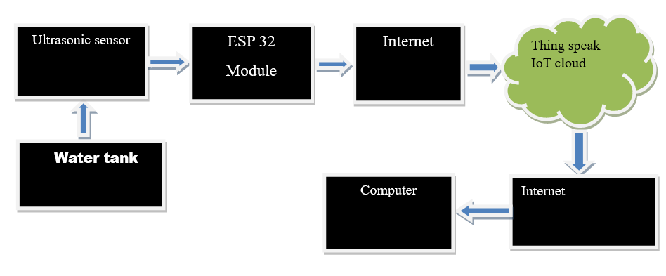

Figure 3.1 7 Block diagram of water monitoring system

### 3.2.2 Methodology:

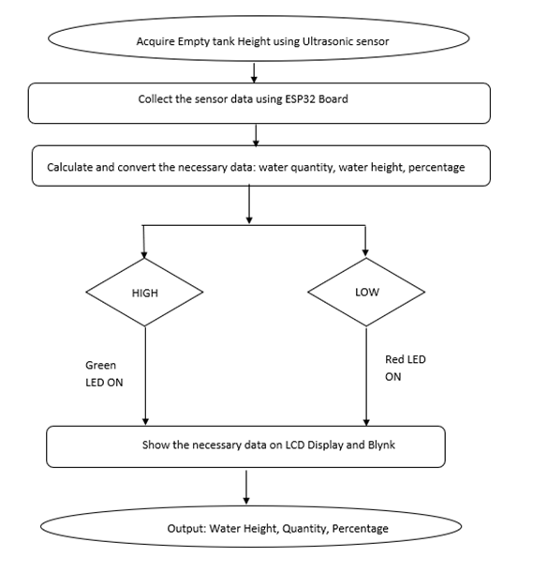

Figure 3.1 8 Methodology of water monitoring system

## 3.3 Program for IoT based water monitoring & Alert system:

#include <Arduino.h>

#include <WiFi.h>

#include <Wire.h>

#include <LiquidCrystal_I2C.h>

#include <ThingSpeak.h>

LiquidCrystal_I2C lcd(0x27, 16, 2);

// char ssid[] = "WATERTANK";

// char pass[] = "60589254";

char ssid[] = "RAJAN";

char pass[] = "rajan123";

const int trigPin = 19;

const int echoPin = 18;

const int redLedPin = 12;

const int greenLedPin = 13;

const int numReadings = 10; // Number of readings to collect for moving average

unsigned int readings[numReadings]; // Array to store readings

unsigned int readIndex = 0; // Index for storing readings

unsigned long total = 0; // Total sum of readings

long duration;

long distance;

float waterHeight;

float tankHeight = 304;

float tankLength = 477;

float tankBreath = 353;

float tankVolume = 51187824;

float waterQuantity;

float volume;

float waterHeight_ft;

int percentage;

float offset = 3030858;

WiFiClient client;

const char *thingSpeakAddress = "api.thingspeak.com";

const char* apiKey = "YWNX16X7HGN7068D";

const unsigned long channelID = 2465169;

unsigned long lastLCDUpdate = 0; // Variable to store the time of the last LCD update

unsigned long lastThingSpeakUpdate = 0; // Variable to store the time of the last ThingSpeak update

const unsigned long LCDUpdateInterval = 2000; // Update LCD every 2 seconds

const unsigned long ThingSpeakUpdateInterval = 60000; // Update ThingSpeak every 5 minutes

unsigned int getDistance() {

digitalWrite(trigPin, LOW);

delayMicroseconds(2);

digitalWrite(trigPin, HIGH);

delayMicroseconds(10);

digitalWrite(trigPin, LOW);

unsigned long duration = pulseIn(echoPin, HIGH);

return duration * 0.034 / 2;

}

unsigned int movingAverage() {

total -= readings[readIndex];

readings[readIndex] = getDistance();

total += readings[readIndex];

readIndex = (readIndex + 1) % numReadings;

return total / numReadings;

}

void ultrasonic() {

unsigned int averageDistance = movingAverage();

volume = 168381 * averageDistance;

waterHeight = tankHeight - averageDistance;

waterHeight_ft = waterHeight * 0.0328084;

waterQuantity = tankVolume - volume + offset;

percentage = (waterQuantity / tankVolume) * 100;

Serial.print("Average distance [cm]: ");

Serial.println(averageDistance);

Serial.print("Water height [cm]: ");

Serial.println(waterHeight);

Serial.print("Water height [ft]: ");

Serial.println(waterHeight_ft);

Serial.print("Water Volume [l]: ");

Serial.println(waterQuantity / 1000);

Serial.print("Percentage filled: ");

Serial.print(percentage);

Serial.println("%");

Serial.println();

if (waterHeight <= 60) {

digitalWrite(redLedPin, HIGH);

digitalWrite(greenLedPin, LOW);

} else if (waterHeight >= 270) {

digitalWrite(redLedPin, LOW);

digitalWrite(greenLedPin, HIGH);

} else {

digitalWrite(redLedPin, LOW);

digitalWrite(greenLedPin, LOW);

}

lcd.clear();

lcd.setCursor(0, 0);

lcd.print("Height: ");

lcd.print(waterHeight_ft);

lcd.print(" ft");

lcd.setCursor(0, 1);

lcd.print("Quant.: ");

lcd.print(waterQuantity / 1000);

lcd.print(" lit.");

}

void connectToWiFi() {

lcd.clear();

lcd.setCursor(0, 0);

lcd.print("Connecting...");

WiFi.begin(ssid, pass);

unsigned long startTime = millis();

}

while (WiFi.status() != WL_CONNECTED && millis() - startTime < 10000) {

delay(500);

Serial.print(".");

}

if (WiFi.status() != WL_CONNECTED) {

lcd.clear();

lcd.setCursor(3, 0);

lcd.print("Failed to ");

lcd.setCursor(7, 1);

lcd.print("connect! ");

delay(5000);

lcd.setCursor(0, 0);

lcd.print(" JIET JODHPUR ");

lcd.setCursor(0, 1);

lcd.print(" RAJAN Kr.(ECE) ");

delay(5000);

lcd.clear();

lcd.setCursor(0, 0);

lcd.print(" WATER TANK ");

lcd.setCursor(0, 1);

lcd.print(" LEVEL ");

delay(3000);

ultrasonic();

} else {

lcd.clear();

lcd.setCursor(0, 0);

lcd.print(" JIET JODHPUR ");

lcd.setCursor(0, 1);

lcd.print(" RAJAN Kr.(ECE) ");

delay(5000);

lcd.clear();

lcd.setCursor(0, 0);

lcd.print(" WATER TANK ");

lcd.setCursor(0, 1);

lcd.print(" LEVEL ");

delay(3000);

lcd.clear();

lcd.setCursor(0, 0);

lcd.print("Connected to");

lcd.setCursor(5, 1);

lcd.print("WiFi!");

delay(2000);

}

}

lcd.clear();

lcd.setCursor(0, 0);

lcd.print(" WATER TANK ");

lcd.setCursor(0, 1);

lcd.print(" LEVEL ");

delay(3000);

lcd.clear();

lcd.setCursor(0, 0);

lcd.print("Connected to");

lcd.setCursor(5, 1);

lcd.print("WiFi!");

delay(2000);

}

}

void setup() {

Serial.begin(115200);

lcd.init();

lcd.backlight();

pinMode(trigPin, OUTPUT);

pinMode(echoPin, INPUT);

pinMode(redLedPin, OUTPUT);

pinMode(greenLedPin, OUTPUT);

connectToWiFi();

ThingSpeak.begin(client);

}

void loop() {

unsigned long currentMillis = millis();

// Update LCD every 2 seconds

if (currentMillis - lastLCDUpdate >= LCDUpdateInterval) {

ultrasonic(); // Call the ultrasonic function to update LCD

lastLCDUpdate = currentMillis; // Update the last LCD update time

}

lcd.setCursor(0, 0);

lcd.print(" WATER TANK ");

lcd.setCursor(0, 1);

lcd.print(" LEVEL ");

delay(3000);

lcd.clear();

lcd.setCursor(0, 0);

lcd.print("Connected to");

lcd.setCursor(5, 1);

lcd.print("WiFi!");

delay(2000);

}

}

// Update ThingSpeak every 5 minutes

if (currentMillis - lastThingSpeakUpdate >= ThingSpeakUpdateInterval) {

// Call the ultrasonic function to update data

ultrasonic();

// Send data to ThingSpeak

ThingSpeak.setField(1, waterHeight_ft);

ThingSpeak.setField(2, waterQuantity / 1000);

ThingSpeak.setField(3, percentage);

int statusCode = ThingSpeak.writeFields(channelID, apiKey);

if (statusCode == 200) {

Serial.println("Data sent to ThingSpeak successfully!");

} else {

Serial.print("Failed to send data to ThingSpeak. Status code: ");

Serial.println(statusCode);

}

lastThingSpeakUpdate = currentMillis; // Update the last ThingSpeak update time

}

}

## 3.4 Visualization and monitoring

The system gives users several options for keeping an eye on the condition of their water tanks. Users can access real-time data and receive alerts via a mobile app, allowing them to quickly address any issues that arise. In addition, the system offers visual graphs and charts to track water levels and usage over time, making it easy for users to make informed decisions about their water consumption. With these advanced monitoring features, users can have peace of mind knowing that their water tanks are always functioning optimally.

### **3.4.1 LCD Screen:**

Immediate visual information regarding water levels is available on an LCD panel. Users can easily see the current water levels without needing to access a separate device or interface. This makes it convenient for users to quickly assess the situation and take the necessary actions. The LCD screen also displays alerts and notifications for when water levels are low or when maintenance is required. This real-time information allows users to stay on top of any issues that may arise, ensuring that their water tanks are always in good working condition. Additionally, the user-friendly interface of the LCD screen makes it simple for users to navigate and understand the data being presented, further enhancing the overall user experience.

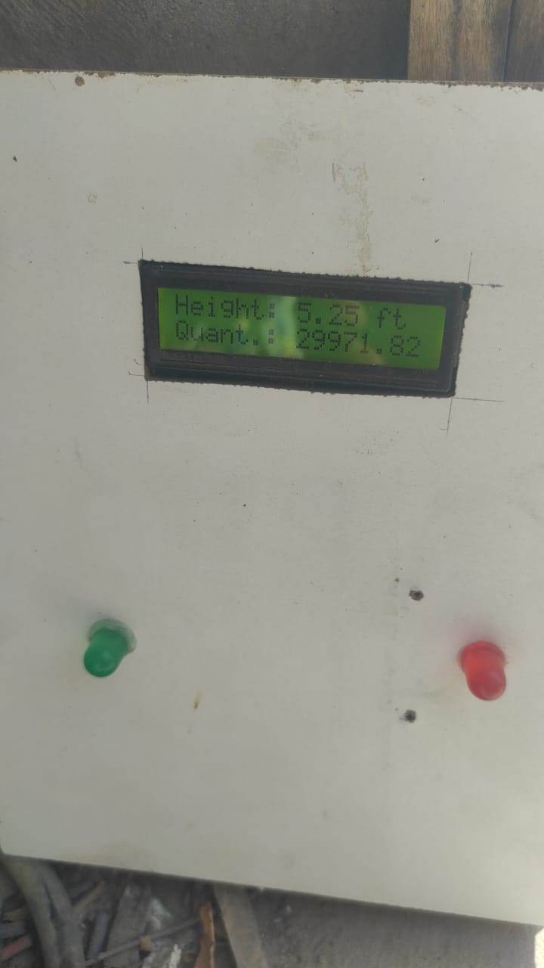

Figure 3.1 9 Output on LCD Display

### **3.4.2 Thing speak:**

Additionally, the system also provides options for remote monitoring through a mobile app or web interface, allowing users to check on their water tanks from anywhere. This level of visualization and monitoring ensures that users are always informed and prepared to handle any potential issues with their water supply. The system integrates with Thing Speak software, which allows users to track historical data and set up alerts for specific water level thresholds. This added functionality provides users with even more control and peace of mind when it comes to managing their water supply. Overall, the combination of real-time monitoring, remote access, and historical data tracking makes this water level monitoring system a comprehensive and efficient solution for users looking to effectively manage their water resources.

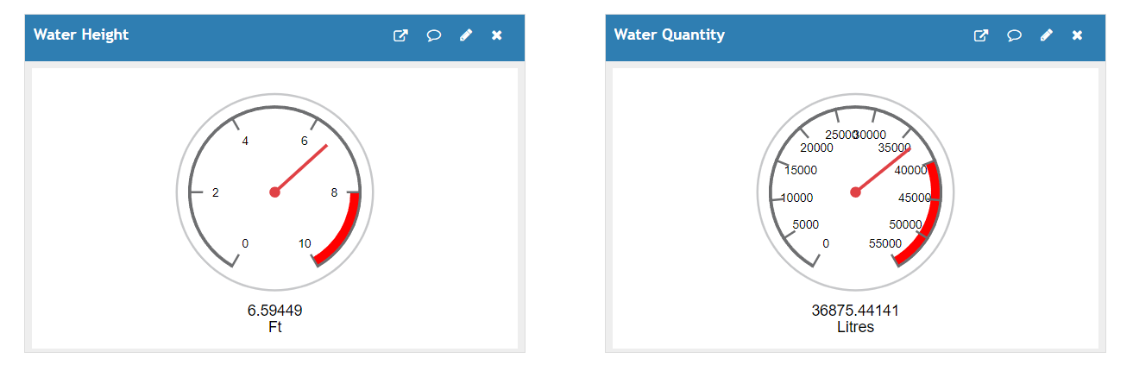

Figure 3.1 10 Output on Thing Speak Server

### 3.4.3 Graphical Representation:

To further enhance user comprehension, the IOT Based Water Level Monitoring and Alert System utilizes a graphical representative webpage that fetches the data and shows it in the format of a numeric, gauge, chart, and table. This allows users to easily monitor and interpret the water levels in real-time. The system's user-friendly interface makes it simple for individuals to stay informed about their water supply status and take appropriate action as needed. Additionally, the graphical representation provides a clear visual indication of any fluctuations or abnormalities in liquid levels, enabling users to proactivelyaddress issues before they escalate.By having this visual representation at their fingertips, users can quickly identify any potential problems and make informed decisions about managing their water resources effectively. The ability to customize the display options allows for a personalized experience, catering to individual preferences and needs. With the Water Monitoring and Alert System, users can have peace of mind knowing that they have a reliable tool to keep track of their water levels and ensure the safety and security of their water supply.

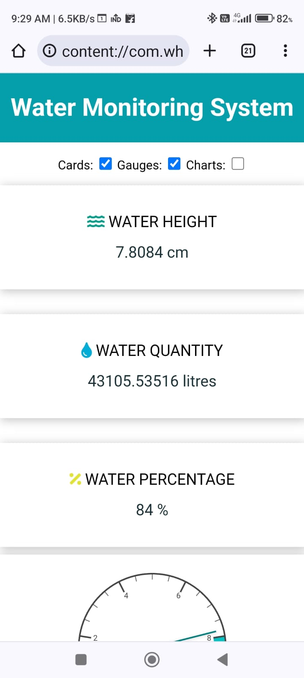

Figure 3.1 11 Webpage Output

## 3.5 Output of IoT based water monitoring & alert System

The IOT Based Water Level Monitoring and Alert System utilizes a graphical representative webpage that fetches the data and shows it in the format of a numeric, gauge, chart, and table. This allows users to easily monitor and interpret the water levels in real-time. The system's user-friendly interface makes it simple for individuals to stay informed about their water supply status and take appropriate action as needed. Additionally, the graphical representation provides a clear visual indication of any fluctuations or abnormalities in liquid levels, enabling users to proactively address issues before they escalate. By having this visual representation at their fingertips, users can quickly identify any potential problems and make informed decisions about managing their water resources effectively. The ability to customize the display options allows for a personalized experience, catering to individual preferences and needs.

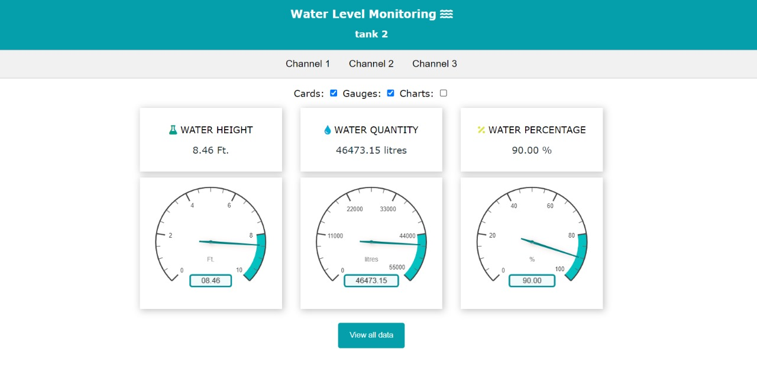

Figure 3.1 12 water monitoring parameters (Height, Quantity, Percentage)

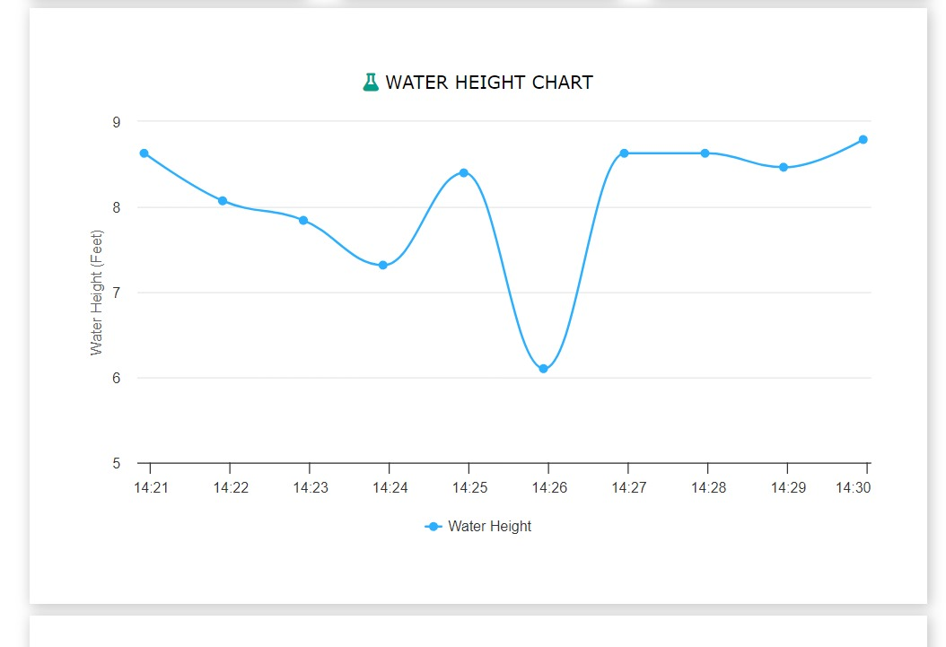

Figure 3.1 13 Water Height chart

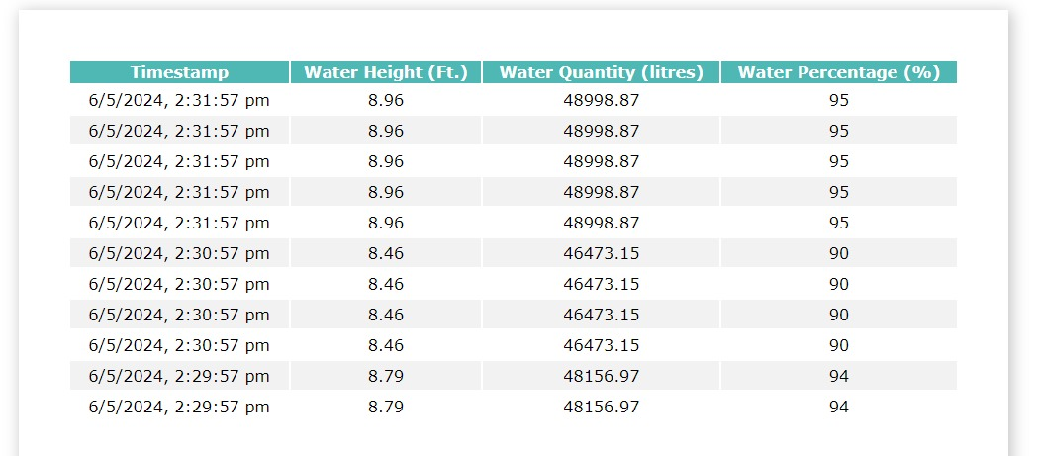

Figure 3.1 14 Tabular data (Continuous monitoring parameters)

## 3.4 Snapshots of working system and installation of system

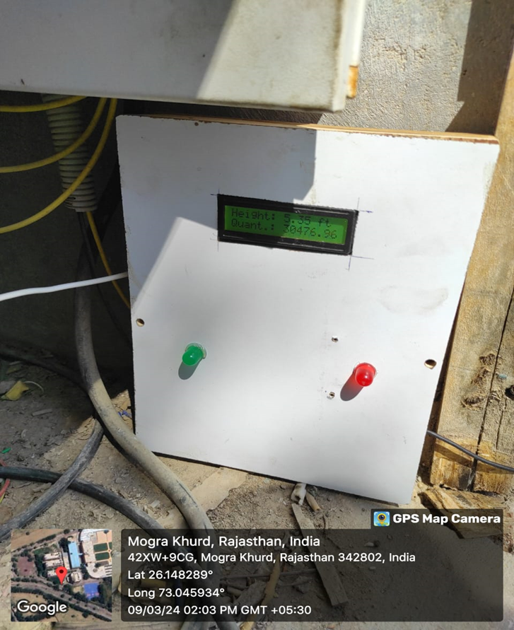

Figure 3.1 15 IoT based water monitoring and alert system

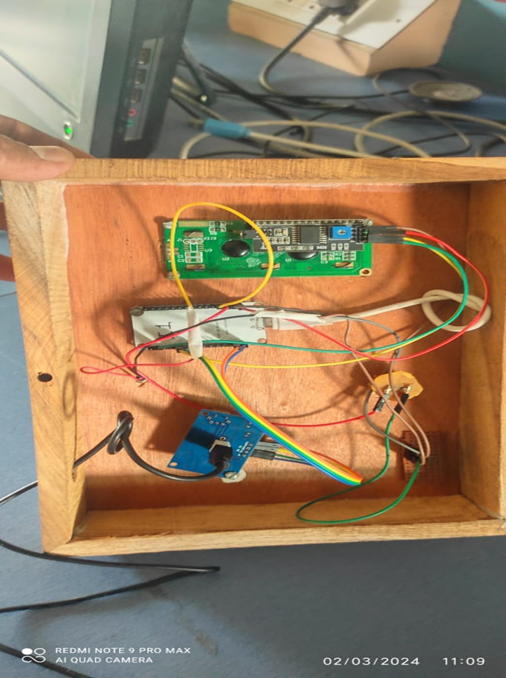

Figure 3.1 16 Circuitry of the system

CONCLUSION

In conclusion, the IoT-based Water Level Monitoring and Alert System presented in this project represents a significant advancement in the field of water management and conservation. By leveraging modern technologies such as ultrasonic sensors, ESP32 microcontrollers, and internet connectivity, the system offers an innovative solution to the pressing challenges of water scarcity and waste.

Through the implementation of this system, users can accurately monitor the levels of liquid in containers in real-time, enabling timely interventions to prevent overflow or depletion. The integration of an alert mechanism further enhances the system's utility by providing immediate notifications to users when critical thresholds are reached.

Moreover, the system's user-friendly interface, accessible through both LCD displays and remote mobile and web applications, ensures ease of use and convenience for users. The graphical representation of data, facilitated by platforms like Thing Speak, allows for comprehensive monitoring and analysis of water levels over time.

Overall, the IoT-based Water Level Monitoring and Alert System offers a holistic solution to water management challenges, promoting efficient utilization of resources and contributing to environmental sustainability. By providing accurate data on water levels, this system can help prevent disasters such as flooding and minimize water waste. The ability to remotely monitor water levels through mobile and web applications also makes it a valuable tool for water authorities and utility companies. With its advanced technology and user-friendly design, the IoT-based Water Level Monitoring and Alert System is poised to revolutionize water management practices worldwide.

This project demonstrates the effectiveness of technology in solving practical issues and emphasizes the value of interdisciplinary cooperation in bringing about constructive change. As we advance, let's work to fully utilize technology in order to build a more just and sustainable society for coming generations.

# REFERENCES

[1] A. A. M. Eltaieb and Z. J. Min, “Automatic Water Level Control System”, Int. J. Sci. Res., vol. 4, no.12, pp. 1505-1509, 2014

[2] Hani, T.M., & Myaing, O.M. (2011). Design and Construction of Microcontroller based Water Flow Control System. Proceeding of International Conference on Circuits, System and Simulation. Bangkok, Thailand.

[3] Pandey et.al (2004), Agricultural Economist, Research Review Vol. 24 January-June 2011 pp 109-118

[4] Olabimpe, A. I. (2010). Design and Construction of Water Pump Control with Level Indicator Project.

[5] Omolola, R. A. (2010). Design and Construction of a Water Detector with pump Control. Project, Department of Electrical

and Computer Engineering, Federal University of Technology, Minna.

[6] Muhd Asran Bin Abdullah (2008), water level in tank using sensor and PID controller, btech. Thesis, University Malasia Saraswak, Saraswak,123p

[7] P. Dietz, W. Yerazunis, D. Leigh, Very Low -Cost Sensing and Communication Using Bidirectional LEDs, UbiComp 2011: Proceedings, vol. 2864, pp. 175`-191, 2003.

[8] M. Javanmard, K.A. Abbas and F.Arvin,“A Microcontroller- Based Monitoring System for Batch TeaDryer”, CCSE Journal of Agricultural Science, Vol. 1, No. 2, December 2012

[9] Hicks, F., Tyler, G.; & Edwards, T.W.Pump Application Engineering- McGraw-Hill Book Company, New York.

[10] Microcontroller Based Automated Water Level Sensing and Controlling: Design and Implementation Issue Proceedings of the World Congress on Engineering and Computer Science, pp 220-225.

[11] S.M. Khaled Reza, Shah Ahsanuzzaman Md. Tariq, and S.M. Mohin Reza, “Microcontroller Based Automated Water Level Sensing and Controlling: Design and Implementation Issue,” Proceedings of the World Congress on Engineering and Computer Science, vol I, 2014.

[12] M. Javanmard, K.A. Abbas, and F. Arvin, “A Microcontroller- Based Monitoring System for Batch Tea Dryer,” CCSE Journal of Agricultural Science, vol. 1, no. 2,2013.

[13] Osama Mahfooz, Mujtaba Memon, and Asim Iftikhar, “Project Review on Water Level Sensing Using PLC,” Journal of Engineering & Technology Science, vol. 2, no. 2, pp. 160-170,2012.